**Controlled Reset on Sunday Morning**

1. Check the uptime on MP-BTS-SA01, MP-BTS-SA02, MP-BTS-SA03 by using the following Splunk search:

* index="perfmon" host=mp-bts-sa*  sourcetype="Perfmon:System" counter="System Up Time"| timechart max(Value) by host

We bounce all 3 servers Sunday morning already; this is just to verify uptime.

2. Shutdown Foresight Workflows on MP-FRS-A01 and MP-FRS-A08

* .\gps fores*|kill

3. Go to MP-BTS-SA03 and open a PowerShell session. Go to D:\Utilities.

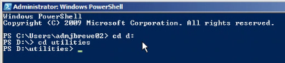

4. Run script:

* .\check-hostsinstances-reset.ps1 -DSTATE down

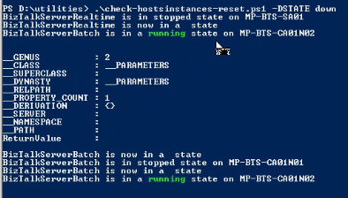

5. While script is running, log into MP-BTS-SA01, MP-BTS-SA02, MP-BTS-SA03 and **SHUTDOWN** IIS

A. Open a command prompt on each server and run IISRESET /STOP

B. After IIS is stopped confirm the status by running IISRESET /STATUS

Examples of the state on each server:

MP-BTS-SA01

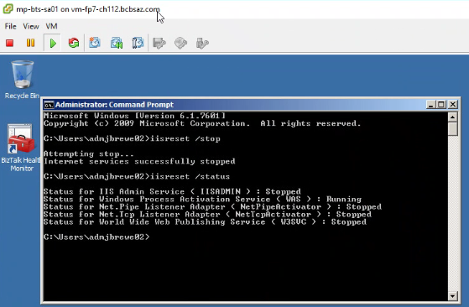

MP-BTS-SA02

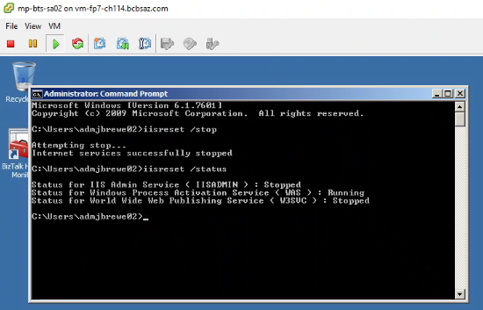

MP-BTS-SA03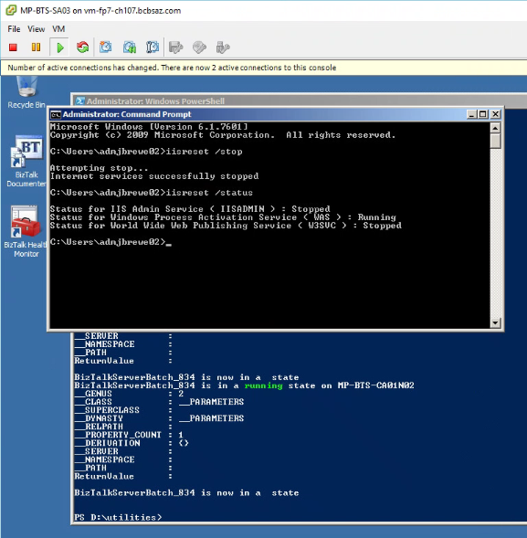

** If services are still running after running the IISRESET /STOP command. Run it again. Check the status again IISRESET /STATUS.

6. By this time the script running in step 4 on MP-BTS-SA03 should be completed.

* *Please verify you are at a prompt in the PowerShell window* before shutting down MP-BTS-SD* and rebooting MP-BTS-SS01, MP-BTS-SS02 and MP-SQL-SD08.

Additional steps:

1. *After all BizTalk host instances and IIS instance are stopped*
2. Shutdown the following SQL servers: (preferred order)
3. MP-BTS-SD02
4. MP-BTS-SD04 and MP-BTS-SD05
5. MP-BTS-SD01 and MP-BTS-SD03

7. Once BTS-SD* servers are shutdown, **REBOOT** MP-BTS-SS01, MP-BTS-SS02 and MP-SQL-SD08.

A. After the reboot, log into MP-BTS-SS02, do a quick check of the disks. Open file explorer and verify all disks are present. C:\, D:\, P:\, Z:\

* + If, drives are not connected, possible reboot again

B. After the reboot on MP-SQL-SD08, make sure SQL is running.

Additional steps:

1. *Once MP-BTS-SS01 and SS02 are confirmed back up*
2. *Start the BizTalk SQL servers in order...*
3. MP-BTS-SD01 and MP-BTS-SD03
4. MP-BTS-SD04 and MP-BTS-SD05
5. MP-BTS-SD02

8. Restart Workflows on MP-FRS-A01 and MP-FRS-A08.

* .\refresh-workflows_gil-wip.ps1

9. Once workflows are up and running, go back to the PowerShell on MP-BTS-SA03 and run script.

A. Run .\check-hostsinstances-reset-v2.ps1

B. While running this script you will see two errors. This is normal because of the cluster.

Additional step:

Run the script .\term-bts-active-wip.ps1 upon completion of .\check-hostsinstances-reset-v2.ps1

10. Once script is finished running, Restart IIS on MP-BTS-SA01, MP-BTS-SA02, MP-BTS-SA03.

A. Run IISRESET /START

B. Verify IIS is **RUNNING** on all three servers. IISRESET /STATUS